

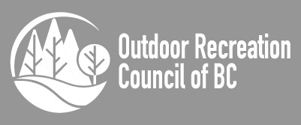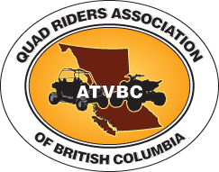

**The residents and businesses of the Cariboo Regional District (CRD) petition the RCMP and CRD for legal access of licensed and insured All Terrain Vehicles and Golf Carts on 50 kph or slower paved and gravel streets/roads to access the Gold Rush Snowmobile Trail and other recreational trails. Access is allowed under Section 24.02 of the Motor Vehicle Act Regulations (MVAR) through an RCMP issued permit allowing access. See ICBC Bulletins MV1445 and MV1815.**

* **Many Canadian Provinces, USA States and countries allow ATVs on rural community roads.**
* **Currently, 37 rural communities in BC allow access to community roads.**
* **Encourages tourism and economic diversification.**
* **Environmentally friendly.**
* **Reduces RCMP callout work load.**

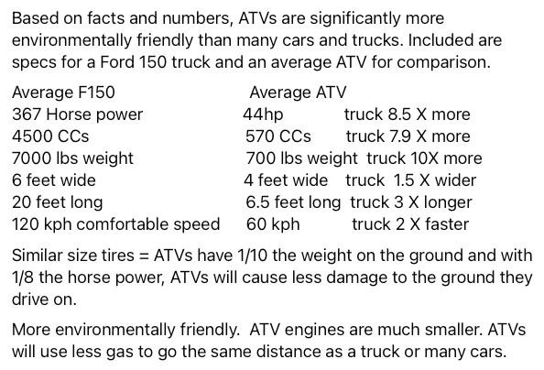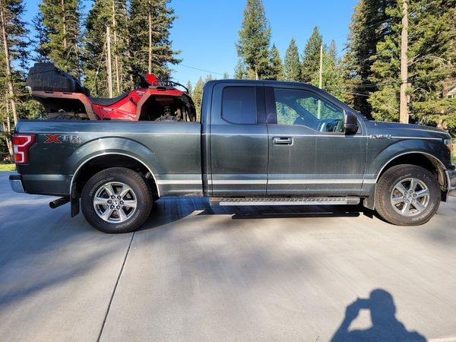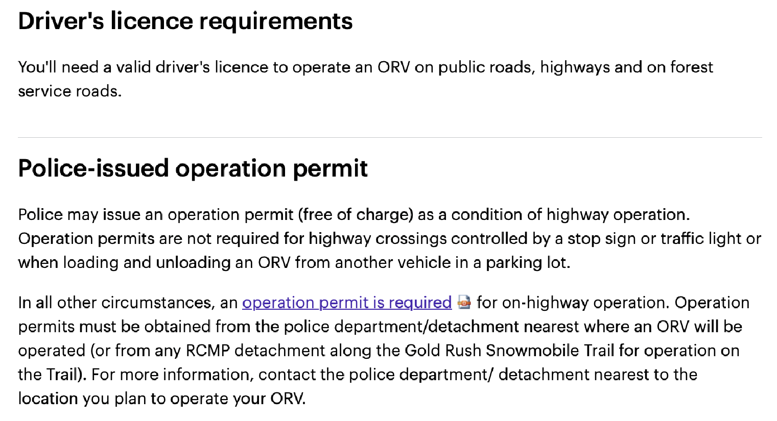

**ATV Road Permit Petition**

**The residents and businesses of the Cariboo Regional District (CRD) petition the RCMP and CRD for legal access of licensed and insured All Terrain Vehicles and Golf Carts on 50 kph or slower paved and gravel streets/roads to access the Gold Rush Snowmobile Trail and other recreational trails. Access is allowed under Section 24 of the Motor Vehicle Act through an RCMP issued permit allowing access, See ICBC Bulletins MV1445 and MV1815.**

|  |  |  |  |
| --- | --- | --- | --- |
| **Name** | **Signature** | **Residing** | **Date** |
|  |  |  |  |
|  |  |  |  |
|  |  |  |  |
|  |  |  |  |
|  |  |  |  |
|  |  |  |  |
|  |  |  |  |
|  |  |  |  |
|  |  |  |  |
|  |  |  |  |
|  |  |  |  |
|  |  |  |  |
|  |  |  |  |
|  |  |  |  |
|  |  |  |  |
|  |  |  |  |
|  |  |  |  |
|  |  |  |  |

**Please return completed petitions to** [**CRDroadaccesspetition@gmail.com**](mailto:CRDroadaccesspetition@gmail.com)

**To print out more copies, please go to** [**https://www.108atvclub.ca/**](https://www.108atvclub.ca/)**petitions**

**Thank you! With your help and support, ATVing in the Cariboo will be more FUN!**